AUTOMATED CLOTH CONFIGURATION SYSTEM

SIX WEEKS INDUSTRIAL TRAINING

SUBMITTED IN PARTIAL FULFILLMENT OF THE REQUIREMENT FOR THE AWARD OF THE DEGREE OF

BACHELOR OF TECHNOLOGY

(COMPUTER SCIENCE ENGINEERING)

#### SUBMITTED BY

JASLEEN KAUR

College Roll No-95132

University Roll No-90370305174



PUNJAB TECHNICAL UNIVERSITY

JALANDHAR, INDIA

**ACKNOWLEDGEMENT**

At the very onset, I am highly indebted to **One Infonet Technology, Ludhiana** for giving me an opportunity to carry out my project on **“Automated Cloth Configuration System”** at their esteemed organization.

I would specially thank **Miss Gaganpreet Kaur**, Project Guide of One Infonet Technology, Ludhiana for giving time and guidance throughout my training without whom it would have been impossible to attain success. My heartiest thanks to Trainees and employees at One Infonet Technology, Ludhiana for helping me throughout the project tenure.

I owe my regards to the entire faculty of the department of computer science engineering at  **Guru Nanak Dev Engineering College,Ludhiana** from where I have learnt the basics of Computer Science and whose informal discussions and able guidance became light for me in the entire duration of this work.

**TABLE OF CONTENTS**

INTRODUCTION 4

I. COMPANY PROFILE 4

II. PROJECT DESCRIPTION AND OVERVIEW 5

IMPLEMENTATION & TECHNOLOGY USED 9

I. JAVA:- 9

II. JAVA SWINGS:- 10

III. NetBeans IDE:- 12

IV. JDBC:- 15

V. SQL:- 16

VI. OPERATING SYSTEM:- 16

VII. System Development Life Cycle 21

PROJECT LEGACY 28

I. CURRENT STATUS 28

II. FUTURE SCOPE 28

LIST OF TABLES AND FIGURES 30

I. DATABASE TABLES 30

II. DFD’s / E-R DIAGRAMS 31

APPENDIX 33

I. SNAPSHOTS 33

CONCLUSIONS 39

BIBLIOGRAPHY & REFRENCES 40

INTRODUCTION

1. COMPANY PROFILE

**Foundation**

OIT has been founded by group of senior IT Professional under the Leadership of Mr. Prabhjot Singh since 1st Sept, 2006. Right from the inception of this start up, OIT has prospered by Leaps and bounds in technology products and critical solutions. Our technologies are acknowledged by leading names of the industry such as Sun Microsystems, Oracle, Computer Associates etc.

Within the span of three years, OIT is the strong team of more than 40 members having its operations based in New York, Noida, Mumbai and Ludhiana.

**Achievements**

OIT believes in innovation and it is evident from various technology breaks through like from fastest database management systems to Desktop Retail Applications integrated with highly innovative data centre services which OIT has achieved in a short span. Our achievements represent our capabilities and expertise in catering directly to the problematic area of a business enterprise.

OIT works along with the client to improve its business outcomes by exploring new business opportunities, deriving cost takeouts, increasing process efficiency without any major change. From innovative ideas to their implementation and thereafter, OIT offers all business transformation outsourcing services to clients under one flagship in four different phases of consulting, developing, outsourcing and training.

**Business Domains**

* **Training-:** From corporate training to end user training and technical Trainings like System Administration, Enterprise Architecture, Enterprise Network etc, OIT has client based dedicated training programs to ensure client can take maximum advantage of our system, services and solutions.

**Professional Learning:-**

* + Web Application Development
  + Software Development
  + Database Administration
  + Advance Networking Solutions
  + Graphics and Animations
  + Project Engineering & Management

**Student Coaching**

* + Sun Certifications
  + Cisco Certifications
  + Microsoft Certifications
  + Oracle Certifications
  + Redhat Certifications

1. PROJECT DESCRIPTION AND OVERVIEW

**Objective:**

To fabricate a automated cloth configuration system for representative to carry out various dealings and embellishments in an easier and faster way to achieve efficiency, accuracy and satisfaction.

**Project Overview:**

|  |  |  |
| --- | --- | --- |
| **Project Name** | **:** | Automated Cloth Configuration System |
| **Company** | **:** | **ONE INFONET TECHNOLOGIES** |
| **Project Type** | **:** | Desktop Application |
| **Front End** | **:** | Java ,swings, AWT. |
| **Tool** | **:** | NetBeans IDE 6.9.1 |

1. **Existing System:-**

The existing system is based on a Manual System. It does not provide the user a faster and easy way to access different types of clothing items. Selection is not made easily. Manual selection process and stock maintenance is not easy, as stock is managed manually on paper itself. It is not easy to update the stock and variety every now and then. The billing receipts are made manually. This task is quite error prone.

Since records are maintained on paper, it can create confusion if papers are misplaced due to some reasons. Moreover, we cannot access the past shopping record of an individual. An individual does not have direct access to clothing item of his/her choice. Shopkeeper keeps on displaying the clothing item to an individual whether he/she likes it or not. This leads to time wastage of both shopkeeper and the individual.

Also they are exposed to all sort of natural calamities like fire, theft etc. This may result in loss of all important papers and even the clothing items present in the shop. Thus the necessity of automation is being raised.

1. **Need of New System:-**

There has been felt the new to switch from Manual System to computer based system because the existing system has the following drawbacks:-

* Lack of Proper Interface:

The existing system is not computerized hence it does not provide graphical interface to the users.

* Difficulty in finding the details of the customer:

To find details of particular customer about its previous shopping record is very time consuming. As manually, it had to search each and every paper to find the particulars.

* No Provision for new customer:

It is necessary to keep a track of all the new customers which currently is not kept by the existing system.

* Cumbersome:

Handling and maintenance of stock is cumbersome.

* Time Wastage:

The biggest problem of existing system is that all the operations are time consuming like entering of all the records manually.

* High Cost:

Lot of paper work and storage is needed to keep back up of records. Also a lot of money is wasted in hiring of personnel and buying stationery.

* Mishandling:

Mishandling of registers, stock records can cause a great deal of confusion.

* High Maintenance:

Manual Record handling requires high maintenance in terms of regular updation so as to facilitate easy handling and maintenance.

1. **Objectives of Proposed System:-**

The objectives of the proposed system are as follows:-

* To facilitate easy retrieval of data and information.
* To update various files after input processing and validations.
* To simplify the present manual task.
* To reduce the precious time, manpower and paper work.
* To maintain different databases on the system, thus storage space and lot of paper is saved.
* To provide timely and valuable information to the customer.
* To provide menu driven, user friendly system.
* To provide faster and easy access to data.
* To provide easier selection procedure to the customer.
* To enable the customer to update the selection done.

1. **Proposed System:-**

This system will switch from the manual system to computerised system. The “Automated Cloth Configuration System” is developed for easy and faster selection of the clothing system. Previous shopping record of the customer is also maintained for further use. This shopping record consist previously bought items with their price and product code.

The customer selects a particular clothing item by selecting a particular category and colour. The customer gets the view of clothing item with product code and price. A special feature of this project is shopping cart in which all the items selected by the customer are present. Items in shopping cart can also be updated either by deleting or adding an item. Automatic billing feature is also present in this proposed system in which billing of all the items is done automatically. Each bill is given a unique number and entries of the bill are maintained in a record. The bill which is generated can also be printed.

A proper computerized system can also become a plus point as a marketing strategy as well as increasing standards of the company. It portrays goodwill and image of the Company. The system also provides valuable and timely information by searching for the particular customer. This project aims at increasing efficiency and decreasing redundancy.

1. **Software/Hardware Requirements:-**

* Hardware:-

Processor : 1.70 GHz and Above

Main Memory : 512 MB.

Hard Disk : 20 GB.

Disk Space : 100 MB.

Floppy Disk Drive : 1.44 MB.

CD ROM Drive : 52x Samsung CD ROM

* Software:-

Operating System : Windows 7/Windows Vista

Software : NetBeans IDE

Data Base : MySQLServer 5.0

IMPLEMENTATION & TECHNOLOGY USED

1. JAVA:-

The entire component has been developed using Java technology. Java has been chosen as the platform because of its feature rich nature. The Java Platform provides robust end-to-end solutions for networked applications as well as a trusted standard for embedded applications. So Java was a natural choice for development process.

**Characteristics of Java:-**

* **Object Oriented**:

Java is object oriented to the truest sense of the word. Everything in Java is represented as objects. Variables and methods both are encapsulated

in objects. Java is the purest object-oriented language.

* **Robust**:

Java is a very robust language owing to the following features. Excellent exception handling facilities. Memory management relief for the user. User does not have to worry about allocation and deallocation of memory. Strict compile-time and runtime checks for data types.

* **Portable and Architecture-neutral (Platform Independent):**

Java is portable and platform independent so much that they satisfy “write once;run anywhere, anytime, forever”. This feature is implemented in the following ways:

* Compiler generates machine independent byte-code instructions which can be run on any machine supporting **Java Virtual Machine**.
* Size of primitive data type is machine independent.
* **Multithreaded:**
* Programs can do many things simultaneously using different threads.
* Provides a solution for multiprocess synchronization.
* Allows the creation of networked and interactive programs.
* **Distributed:**
* Open access to remote objects by the use of RMI(Remote Method Invocation).
* Brings a level of abstraction to client/server programming.
* **Secure:**
* Security is achieved by confining a java program to the java execution environment and not allowing access to other parts of the user computer.
* Absence of pointers provides memory related security as encroachment of memory is avoided Proper measures for prevention of viral infection and malicious intent.
* **Dynamic and Extensible:**
* Facilitates linking in of new classes, objects and methods.
* Supports native methods (methods written in other languages like C, C++).
* Programs carry with them a substantial amount of runtime type information that is used to verify and resolve accesses to objects at run-time.
* **High Performance:**

Just-In-Time (JIT) compilers are used to convert byte-code into native machine code resulting in very high performance. These JIT compilers can be used on a real time, piece by piece demand basis to perform on-the-fly compilation of byte-code into native-code.

* **Compilation and Interpretation:**
  + - Java programs are implemented as a two-stage system.
    - Compilation: Source code to byte-code and not machine instructions.
    - Interpretation: Byte-code to machine code (for any system that supports Using JVM). Thus cross-platform programs can be written.

1. JAVA SWINGS:-

"Swing" refers to the new library of GUI controls (buttons, sliders, checkboxes, etc.) that replaces the somewhat weak and inflexible AWT controls.

The Swing classes eliminate Java's biggest weakness: its relatively primitive user interface toolkit. Java Swing helps you to take full advantage of the Swing classes, providing detailed descriptions of every class and interface in the key Swing packages. It shows you how to use all of the new components, allowing you to build state-of-the-art user interfaces and giving you the context you need to understand what you're doing. It's more than documentation; *Java Swing* helps you develop code quickly and effectively.

* **Main New Features:**
* Lightweight: Not built on native window-system windows.
* Much bigger set of built-in controls: Trees, image buttons, tabbed panes, sliders, toolbars, color choosers, tables, text areas to display HTML or RTF, etc.
* **Much more customizable**. Can change border, text alignment, or add image to almost any control. Can customize how minor features are drawn. Can separate internal representation from visual appearance.
* **"Pluggable" look and feel**. Can change look and feel at runtime, or design own look and feel.
* **Many miscellaneous new features**. Double-buffering built in, tool tips, dock able tool bars, keyboard accelerators, custom cursors, etc.
* **Components are named J*Xxx*.**

E.g. JFrame, JPanel, JApplet, JDialog, JButton etc.

**J Component:-**The J Component class is the root of the Visual component class hierarchy in JFC. All Swing components are implemented as subclass of J components class, which inherits from the Container class. Swing component inherit the following functionality from J Component.

* Borders- Using the setBorder() method, you can specify the border that a component displays around its edges. You can specify that component have extra space around its edges using an EmptyBorder instance.
* Double Buffering- It can improve the appearance of frequently changing components. Now you do not have to write the double buffering code because Swing provides it for you. By default Swing components are double buffered.
* Tool Tips- By specifying a string with the setToolTipNext() method, you can provide help to users of a components. When the cursor pauses over the components, the specified string is displayed in small window near the component.
* Look and Feel- Subject to the security restriction, you can choose the look and feel used by all Swing components by invoking the UIManager.setLookAndFeel() method.
* There is an almost-equivalent Swing component for most AWT components.
* Instead of adding components directly to frames or applets, we can use the content pane.
* Add to content pane via getContentPane().add
* Replace content pane via setContentPane().

* Model-View-Controller architecture let us change the internal data representation for lists, trees, tables, etc.
* Swing was in the com.sun.java.swing package in beta releases of 1.2. Switched to javax.swing in 1.2 final.
* Default "look and feel" is a Java-specific one.
* Need special call to get native look
* Default called "Java look & feel"
* Mixing AWT and Swing is doomed.

AWT components are always on top, and z-ordering problems catch you in many unexpected ways. Stick with the AWT or move completely to Swing.

1. NetBeans IDE:-

The **NetBeans Platform** is a reusable framework for simplifying the development of Java Swing desktop applications. The NetBeans IDE bundle for Java SE contains what is needed to start developing NetBeans plugins and NetBeans Platform based applications; no additional SDK is required.

Applications can install modules dynamically. Any application can include the Update Center module to allow users of the application to download digitally signed upgrades and new features directly into the running application. Reinstalling an upgrade or a new release does not force users to download the entire application again.

The platform offers reusable services common to desktop applications, allowing developers to focus on the logic specific to their application. Among the features of the platform are:

* User interface management (e.g. menus and toolbars)
* User settings management
* Storage management (saving and loading any kind of data)
* Window management
* Wizard framework (supports step-by-step dialogs)
* NetBeans Visual Library
* Integrated Development Tools

**NetBeans IDE** is an open-source integrated development environment. NetBeans IDE supports development of all Java application types (Java SE including JavaFX, (Java ME, web, EJB and mobile applications) out of the box. Among other features are an Ant-based project system, Maven support, refactoring, version control (supporting CVS, Subversion, Mercurial and Clearcase).

**Modularity**: All the functions of the IDE are provided by modules. Each module provides a well defined function, such as support for the Java language, editing, or support for the CVS versioning system, and SVN. NetBeans contains all the modules needed for Java development in a single download, allowing the user to start working immediately. Modules also allow NetBeans to be extended. New features, such as support for other programming languages, can be added by installing additional modules. For instance, Sun Studio, Sun Java Studio Enterprise, and Sun Java Studio Creator from Sun Microsystems are all based on the NetBeans IDE.

**NetBeans IDE is much more than a Java IDE: We designed NetBeans IDE as a modular developer tool for a wide range of development tasks. The base IDE includes an advanced multi-language editor, debugger and profiler integration, file versioning control, and unique developer collaboration features**

* **IDE-wide QuickSearch**

Use the Ctrl-i shortcut to do a context-sensitive search throughout the IDE, the help sets, and all open projects. You will find the search term not only in files, types or symbols, but also all related menu actions, option panels, and documentation.

* **Custom Installer**

Select the NetBeans IDE download that provides the features you need. You can either choose the download with all features and then configure the installation so that only the features you need actually get installed; or you choose one of the smaller downloads that has only a subset of the features

* **Plugin Manager**

You can always use the Plugins Manager from the Tools menu to add, remove, or update sets of features for Java SE, Java EE, Java ME, Groovy, PHP, C/C++, or SOA development, including a wide variety of other features from third-party providers.

* **Customize Your Projects**

Set up properties and compilation dependencies between your projects, and use relative library paths to make projects sharable. Store various project configurations for different development phases. The IDE builds binary executables and archive files in a number of formats, including JAR, WAR, EAR, NBM, JNLP Web Start, and ZIP files, ready for distribution.

* **Templates and Sample Applications**

You can create a free-form projects based on an existing build script and sources, or start projects from a template. The IDE comes with templates and sample projects for Java SE applications, mobile applications, web applications, enterprise applications, NetBeans plugins, Groovy, PHP, and C and C++ applications.

* **Databases and Services**

The Services window gives you access to all your databases and web servers, as well as web services and enterprise JavaBeans (EJBs). You can start and stop servers, and drag and drop web services and EJBs into your projects.

* **Task List**

The NetBeans Task List automatically scans your code and lists commented lines containing words such as "TODO" or "FIXME", and lines with compile errors, quick fixes, and style warnings. Connect to a bug database (e.g. Issuezilla, Bugzilla, java.net, Scarab) and list issue reports for your project right in the IDE. You can always import and export your task lists in standard iCalendar format.

* **Sliding Windows**

The IDE's workspace is fully customizable: Customize the actions in the toolbar and drag and reposition tabs in the IDE window to suit your individual workflow.

* **Multiple Monitors**

Undock any editor tab by dragging and dropping it outside the IDE: It will turn into an independent window that you can move to a second screen. To reintegrate the tab into the IDE window, drag and drop it back.

* **Project Groups**

Project groups allow you to define sets of related projects. This allows you to quickly open and close several grouped projects in one step.

1. JDBC:-

The JDBC is a set of the database access classes. The very term JDBC stands for “Java Database Connectivity”. It was developed by Java Soft. JDBC technology is an API (Application Program Interface) that allows virtual access to any tabular data source from the Java programming language by means of some connecting software called Drivers. It provides cross-DBMS connectivity to a wide range of SQL databases. JDBC defines a set of interfaces to enable developers to access data independently of the actual database product used to store the data. JDBC allow Java applets, Servlets, and application to access data in famous database management systems.

* It also provides access to other tabular data sources, such as spreadsheets or flat files. The JDBC API allows developers to take advantage of the Java platform's "Write Once, Run Anywhere" capabilities for industrial strength, cross-platform applications that require access to enterprise data. With a JDBC technology-enabled driver, a developer can easily connect all corporate data even in a heterogeneous environment. The JDBC API is the industry standard for database-independent connectivity between the Java programming language and a wide range of databases. The JDBC API makes it possible to do three things: Establish a connection with a database or access any tabular data source
* Send SQL statements
* Process the results

**Steps in using JDBC:-**

* Create a Connection type of object (A) denoting a connection to the database.
* Create a Statement type of object (B) using the A.
* Use B to execute either update the database or send a query request.
* The result of the query operation in step 3 is a Result Set type of object(C)
* C is actually a small table (D) consisting of the result of the query.
* D can be handled according to the user needs
* Close C,B and A

1. SQL:-

SQL stands for Structured Query Language, better known as “sequel”. It is used for:

1. Querying a database by editing the SQL statements.

2. Querying a database within a program

3. Defining data organization.

4. Administrating data

5. Accessing multiple data servers

6. Managing transaction.

1. OPERATING SYSTEM:-

This project is implemented both on Windows Vista & Windows 7.

* **Features of Windows Vista:**

**Windows Vista** (formerly codenamed **Longhorn**) has many new features compared with previous Microsoft Windows versions, covering most aspects of the operating system.

This article discusses the changes most likely to be of interest to non-technical users. The companion article, Technical features new to Windows Vista, discusses the technical advancements in Windows Vista, while the article Security and safety features new to Windows Vista discusses the security advancements. The article Management features new to Windows Vista discusses the management and administrative improvements, which may be of interest to IT professionals.

Windows Vista is a great operating system, with many wonderful new features and a huge improvement over its predecessor Windows XP.

There are many, many things to like about this OS. Here are a few features worth looking at:

* **The Visual User Interface is Stunning:**

Whether you like Vista or not, you have to admit, it's pretty – in fact, it’s down right stunning to look at. Everything visually about Vista is better: The high quality resolution displays, menus and transitions between screens and open windows provide the user a much more appealing experience.

* **Gadgets Can Save You Time:**

The Sidebar on the right-hand part of the screen has these little programs called Gadgets. These programs rest on the desktop and automatically update as necessary. Not only does Microsoft provide a bunch of them, but there are literally thousands of free ones on Microsoft’s web site.

* **Snipping Tool Takes Great Screen Shot:**

This tool fills a much needed vacuum for taking screen shots. Before Vista, using the Print Screen or Alt and Print Screen were the only choices. For anyone that needs to take a screen shot to share with someone else, this tool is great, easy to use and more specific than previous methods.

* **SP1 Is Compatible With Third Party Hardware:**

Initially, Vista did not work with many third party drivers and hardware. With SP1 most of the pain and problems associated with this have gone. Recently, I installed a fresh copy of Vista on my laptop. Not only did the SP1 version install flawlessly, it recognized all my devices and I did not have to install additional drivers that would probably just have slowed down the system.

* **It Organized Files More Efficiently:**

Consider for a moment that you still use XP. You have the "My Documents" folder as the default for your work, photos and music. You must create the unique file folders to house those all those files. That's fine, if you are an organized person that can remember where everything is located.

With Vista you have default folders already created for your documents, pictures, videos, music, contacts, favorites, downloads, links, searches and saved games. You can change these if you want, but it sure is nice to have that already set up and ready to go.

* **Good Multimedia Experience:**

The overall multimedia experience is better and more integrated than with XP. I found files that would not work in XP, just work perfectly in Vista – MP3 Video to be specific.

* **Windows Calendar, Contacts and Mail:**

With Windows Vista you get a fully functioning calendar, contacts database and email. It is like getting the Outlook program for free. You can access each program within the other as if they were one program. You could pay more money to get a few more features with an Email program like Outlook, but why would you when these are so feature rich. I am actually very surprised that Microsoft is giving these away with Vista.

* **Windows Backup and Restore Center:**

The problem of how to backup and restore Windows computers has been a boon for third party software makers for years, because Windows had no application to provide that function. Windows Vista has a really good, free backup and restore program that will protect either your whole computer or just your work files. It’s easy to use and works well.

* **It's Free and Included With New Computers:**

You do not have to downgrade and pay for XP to get a great operating system. Windows Vista really is a great OS and will do more for you than XP, if you just take a chance and try it. Learning to use it is easy because not only is there a lot of information available online, but Vista's Help has video tutorials that are very helpful.

* **Easy of Access Center & Mobile PC Center:**

The Ease of Access Center allows users to adjust a variety of settings for display, input devices such as touch pads, mouse and keyboard as well as using a Magnifier and on-screen keyboard display. The Mobile PC Center allows users to configure laptop mobility settings, power options, desktop appearance, Tablet PC settings, special input devices and has a Sync Center for synchronizing windows applications with other computers, mobile devices and network folders.

* **Improved Help Section:**

The Windows Help has been completely redone. It contains lots of information, videos and wizards to make the support experience better. There are also connections to online Microsoft support for those with more questions or problems not addressed in the local help information.

* **Features of Window 7:-**

The Windows 7 operating system shares many features and functions with Windows Vista. It also improves on Vista. Here is a list of features and functions that are unique to Windows 7:

* **Action Center:**

Allows users to see what alerts Windows 7 shows; a handy way to control those annoying UAC messages while not having to disable it.

* **Aero Shake:**

Click and shake one open window and all others on the desktop will minimize.

* **Aero Snap :**

Drag a window to any edge of the display and it will automatically re-size.

* **Aero Link:**

Point to the right edge of the taskbar to watch open windows turn transparent, revealing all your hidden icons and gadgets

* **Aero Templates,Themes:**

New backgrounds and themes unique and created for Windows 7 (including free additional themes downloadable from Microsoft).

* **Device Stage:**

Helps users interact with any compatible device connected to a Windows 7 computer; view device status and run common tasks from a single window. The key words here are "compatible devices."

* **Domain Join:**

Helps business users quickly connect to different office networks.

* **Gadgets (Improved):**

The Sidebar has been eliminated; Gadgets can be placed anywhere; New Gadgets have more functionality.

* **Home Group:**

Enables users to quickly and easily create home networks between computers using Windows 7.

* **Jump Lists:**

Right-click a program icon and see a list of recently used files that use that program.

* **Libraries:**

Make it easier to find, work with, and organize documents, music, pictures, and videos scattered across your PC or network.

* **Location-Aware Printing :**

If you travel between offices or home and office, this feature is handy: Windows 7 remembers which network and printer you're using and automatically switches the default printer to match the one you last used.

* **Multiplayer Games:**

Microsoft has revived 3 XP multiplayer games: Internet Checkers, Internet Spades, and Internet Backgammon.

* **Networking (Improved):**

Improved task bar widget that allows for quick network connection and configuration.

* **Play to function :**

Right-click the music tracks you’d like to hear and select Play To. Play To works with other PCs running Windows 7 and devices compliant with the Digital Living Network Alliance (DLNA) media standard.

1. System Development Life Cycle

**WATERFALL MODEL**

It suggests a systematic, sequential approach to the software development that begins at the system level and progresses through requirement, analysis, design, testing and support phases.

**REQUIREMENT ANALYSIS:**

This phase define the requirement of the software i.e. it defines the tools and equipments which are used for the development of the software.. Following are the hardware and software requirements for building this Application:

Hardware :-

Processor : 1.70 GHz and Above

Main Memory : 512 MB.

Hard Disk : 20 GB.

Disk Space : 100 MB.

Floppy Disk Drive : 1.44 MB.

Keyboard : ANY

Mouse : ANY

Monitor : ANY

CD ROM Drive : 52x Samsung CD ROM

**Software :-**

Operating System : Windows 7

Software : JAVA , AWT,SWINGS

Data Base : MYSQL

**FEASIBILITY STUDY**

Feasibility study is carried out to test is the proposed system is worth being implemented. Given unlimited resources and infinite time, all project are feasible. Unfortunately, such situations are not possible in real time. Hence it becomes necessary and prudent to evaluate the feasibility of the project at earliest possible time in order to avoid unnecessary wastage of time. Feasibility study is the test of the system proposed regarding its work ability, impact or organization’s ability to meet user’s needs and effective use of resources. It is usually carried out by a small group of people who are familiar with the information system technique, understand the part of business that will be involved and affective by the people that are skilled in analysis and design.A feasibility study is conducted to select the best system that meets the performance requirements. This entails an identification description, and emulation of candidate systems and selection of best system for the job.

The factors that should be included in the feasibility assessment can be as follows.

**Cost** : operating, maintenance, unit

**Accuracy**: frequency, significance and correction of errors

**Reliability**: stability, durability

**Capacity**: average, low and peak loads

**ECONOMIC FEASIBILITY:**

Economic analysis is the most frequently used method for evaluating the effectiveness of a candidate system. More commonly known as cost/benefits and saving that are expected from a candidate system and compare them with cost If benefits outweigh costs, then the decision is made to design and implement the system.

Usually cost benefits analysis is made to find the savings or extra overheads that would arise new development. The technique of cost benefit analysis is often used as a basis for assessing economic feasibility. The factors for evaluation are:

* Cost of operation of existing system and proposed system
* Cost of development of proposed system
* Value of benefits of proposed system.

**TECHNICAL FEASIBILITY:**

Technical feasibility centers on existing computer system and to what extent it can support the proposed addition. This involves financial consideration to accumulate technical enhancement. E.g. if the current operating system is at 80% capacity and arbitrary ceiling then running another application could overload the system or require additional hardware. If the budget is serious constraint then the project is not feasible.

**OPERATIONAL FEASIBILITY:**

The operational feasibility refers to the assessment of proposed system in the manner that how much this system is feasible for passenger the end users. The system should have capabilities in it. That person with a simple knowledge can also use the system. Our proposed system is user-friendly interface. The user just have to press the choice with the help of menu. Therefore the system is feasible on operational front too.

Our system will improve the performance and save the time. Also, it will help to remove the errors that may occur by the human operator. Human may undergo many mistakes in the busy enquiry schedule and crowdy and irritating environment.

**SYSTEM ANALYSIS**

Analysis is a detailed study of the various operations performed by a system and their relationship within and outside of the system. In journal view system is collection of people, procedures and equipments. People are not an important component of any information system. Information is produced and used by people in an organization in their everyday activities to make decisions. Information system establishes procedures ensuring that right people receive right data at right time. These procedures determine what is to be done at it enter and passed through the system. System analysis is the method that is used to analyze the system, design them and build them. Analysis is used to gain an understanding of existing and what is required in system. The analysis phase ends with the system description and a set of requirement of the new system. Analysis is a process of diagnosis the situation with the boundaries of system kept in mind to produce a report based own findings. Planning for information system development is done within in the framework of organizations overall MIS plan.

**Identification of need**

Detailed information requirement analysis of organization is collected from present system. As a person has to be changed with the prevailing conditions of society, in the same a system has to be changed accordingly. Computerized organization is the today’s demand. In comparison to the old system, the computerized system is more reliable and cost effective. In the present organization, the data is scattered whereas the data should be integrated at one place so that the modifications can be made easily and it becomes easy for any authorized person to get information from these files.

**Preliminary investigation**

To meet the above-mentioned requirement, we need a system that has the tools of PHP. It should be a simple system because the user going to use it are not much familiar with these kind of systems so it should be a simple, easy to use an understandable to all persons.

**Objectives**

1. Efficiency: when all the work is done by computer then it will increase the efficiency, so all the activities will be done fastly.
2. This system also save time for making test results..

At present time, every person is in hurry, nobody has spare time. Every user wants quick service. With this software, every user will avail every type of services.

The existing system was manual system in which all records were kept in registers. All processing was done manually. All these registers have to be stored for many years to for keeping of the records. For all these, a lot of time was consumed and a number of persons were involved. Different persons keep different records and a lot of place was required to store documents.

Furthermore, when we wanted to see the record of any student, we don't get all the information from one register. One has to go through many registers and from one person to another person to collect all the information, which resulted in wastage of time. The problem could be automating an existing manual process, developing a new automated system, or a combination of the two. The developer has to develop the systems to satisfy the client’s need . The developer usually does not understand the client’s problem domain, and the client often does not understand the issues involved in software systems.

**SYSTEM DESIGN**

The design phase focuses on the detailed implementation for the system recommendation in the feasibility study. The design phase is a translation from a program-oriented-document to user-oriented-document. The design activity begins when the required document for the software to be developed is available. This may be SRS for the complete system, in case of waterfall model is being followed or the requirement for the next iteration, if the iterative enhancement is being followed or the requirement for the prototype if the prototyping is being followed. Design is essentially the bridge between requirement specification and the final solution for satisfying the requirements. The term “design” is used in two ways, when used as a verb it represents the process the designing while it represents the result of design process. The goal of design process is to produce some order, which can be later used to build that system. The produced model is called the design of the system.

The design of the system is essentially a blueprint or a plan for solution for the system. Here we consider a system to be asset of components which clearly defines the behavior that interacts with each other in a fixed define manner. A component of a system can be3 considered as a system with its own components. In a software system a component is a software module.

The design process for software system has two levels, Top level and logical design. In top level, it is indicated that how the modules should be integrated. Logical design expands the system design to contain more detailed description of processing logic and data structures.

Design is essentially the bridge between requirement specification and the final solution for satisfying the requirements. The term “design” is used in two ways, when used as a verb it represents the process the designing while it represents the result of design process.

The goal of design process is to produce some order, which can be later used to build that system. The produced model is called the design of the system. The design of the system is essentially a blueprint or a plan for solution for the system. Here we consider a system to be asset of components which clearly defines the behavior that interacts with each other in a fixed define manner. A component of a system can be considered as a system with its own components. In a software system a component is a software module

**IMPLEMENTATION**

It is one of the main modules of the project development stage. All the work done as earlier comes near to end when I am going to implementing the project. I tried my best to fulfill all the requirements of Automated cloth configuration System. However, implementation can be taken finalize the testing procedure. But if we implement the project there is not any standardized procedure to check the testing while implementation give us chance to test if there is any problem, it can be taken remedies so we can finalize the project, using implementation and reviewing techniques. So far, this project is concerned; it is free from errors and can be implemented very effectively.

**TESTING**

Testing is the major control measure used during software development. Its basic function is to detect errors in the software. During requirement analysis and design, the output is a document that is usually textual and no executable. After the coding phase, computer programs are available that can be executed for testing purpose. This implies that testing not only has to uncover errors introduced during coding, but also errors introduced during previous phase. Thus the goal of testing is to uncover the requirements, design and coding errors in the programs.

**FUNCTIONAL TESTING**

This testing phase includes checking the functionality of the system we have developed. This may include checking the overall functionality and to check the each module one by one. In functional testing the structure of the program is not considered. The basis for deciding the test cases in this is the requirement or the specification of the program or the module. For the entire system the test cases are designed from the requirement specification document for the system. Test cases are given for testing against requirements of the unit being tested. The unit modifies a test databases for the integrity of the databases after the operation. Test cases based on experience such as testing for boundary conditions minimum, maximum and off by one boundary**.**

**PERFORMANCE TESTING**

When a program is tested, the actual output is compared with the expected output. When there is a discrepancy, the sequence of instructions must be traced to determine the problem. The process is facilitated by breaking the program down into self-contained portions, each of which can be checked at certain key points. The idea is to compare program values against desk-calculated values to isolate the problem.

**STRESS TESTING**

The purpose of stress testing is to improve that the candidate system does not malfunction under peak loads. Unlike volume testing, where time is not a factor, we subject the system to a high volume of data over a short time of period. This simulates and online environment where a high volume of activities occurs in spurts.

**CONVERSION**

Conversion means changing from one system to another. The objective is to put the tested system into operation while holding costs, risks and personnel irritation to a minimum. It involves

1. Creating computer-compatible files
2. Training the operating staff
3. Installing terminals and hardware

A critical aspect of conversion is not disrupting the functioning of the organization.

**MAINTAINANCE**

Maintenance is a provision, which includes both the improvement of system functions and the correction of faults which arise during the operating of system. Maintenance activity may require the continuing involvement of a large proportion of computer resources. When we install the software, chances arise in two ways

1. As a part of normal running system where errors are found, user may ask for improvement or external requirements change.
2. As a result of specific investigation and review of system performance.

PROJECT LEGACY

1. CURRENT STATUS

The AUTOMATED CLOTH CONFIGURATION SYSTEM is a fully functional desktop application implemented in JAVA using SQL as a backend. It has two ends

Admin End: The admin is the owner of the system. He has access to prohibited sections of the system like “Add Item”, “Remove Item”, etc.

User End: The user is any ordinary customer who wishes to purchase tem from the store.

The AUTOMATED CLOTH CONFIGURATION SYSTEM has following modules:

* Login: To enter the system the user or admin have to enter their unique username and password assigned to them.
* New user: When a new user wants to access the system, he is given a user form to fill. On submission of the credentials in the form his data goes to the database
* Dynamic Selection: The user has to specify his colour and category specifications of the products he wishes to buy and the system produces a dynamic page according to his needs from which he can choose any item
* Cart: After selecting the item and specifying his quantity the item is to be added to the cart. From this cart the user may delete or update his selection.
* Billing: After the user has finalized his purchases, he has to get a bill of his items. The bill is generated dynamically as per the items in the cart. Each bill has a self-generated bill number which it gets from backend. The bill is first saved to the database and then a printout is taken.
* Recent Purchases: In case the admin has logged in all the purchases made are available for viewing. Otherwise the user can view any purchases he has made in the past.
* Add Item: This privilege is available only to the admin. In this the admin can select an image of item he wishes to add to his collection. Then he has to specify the category, cost and id of his item. Then dynamically two image files of size 70X70 px and 350X350 px are generated and saved in the project folder and the database.
* Remove Item: This privilege is available only to the admin. In this the admin has to specify the product id of the item and the item is deleted from the database.

1. FUTURE SCOPE

AUTOMATED CLOTH CONFIGURATION SYSTEM is currently in its first version but has wide futuristic scope. It will revolutionise the way we shop. It will save us from the hassle of running from one shop to another, long billing queues and shall also save a lot of time. Following modules may be added to the system.

* Online System: The system can be put online. So any user can shop from anywhere he wants.
* Credit cards: Automated payment through credit cards can be included in the system.
* Discounts: The admin can introduce discounts according to his wish.
* Improved categorization: The categorization can be further expanded. New collections according to different ages and tastes can be added. More colour specifications can be added.
* User categorization: The users could be given points on every purchase they make. Then according to those points he would be categorised and given special discounts and provisions.
* Accessories: Other accessories related to clothing like belts, jewellery, etc. could be added for the user.
* Other admin privileges: The admin could be given more privileges like blacklisting a customer could be added. The admin could be given access to the profiles of all the users. Employees could be added by the admin with permissions in between those of user and admin.

LIST OF TABLES AND FIGURES

1. DATABASE TABLES

|  |  |  |  |  |  |  |
| --- | --- | --- | --- | --- | --- | --- |
| **TABLE** | **FIELD** | **DATA TYPE** | **NULL** | **KEY** | **DEFAULT** | **EXTRA** |
| items | 1. Id 2. color 3. category 4. cost | 1. varchar(7) 2. varchar(10) 3. varchar(30) 4. int(11) | YES  YES  YES  YES |  | NULL  NULL  NULL  NULL |  |
| user | 1. Id 2. name 3. last_name 4. gender 5. email 6. address 7. phone 8. username 9. password | 1. int(11) 2. varchar(30) 3. varchar(30) 4. varchar(6) 5. varchar(50) 6. varchar(200) 7. varchar(40) 8. varchar(20) 9. varchar(20) | NO  YES  YES  YES  YES  YES  YES  NO  YES | PRI  UNI | NULL  NULL  NULL  NULL  NULL  NULL  NULL  NULL | auto_increment |
| billing | 1. Idnum 2. Quantity 3. Cost 4. amount | 1. Varchar(20) 2. Int(11) 3. Int(11) 4. Bigint(20) | YES  YES  YES  YES | UNI | NULL  NULL  NULL  NULL |  |
| billing1 | 1. billno 2. idnum 3. quantity 4. cost 5. purchaseDate 6. user | 1. Int(11) 2. Varchar(20) 3. Int(11) 4. Int(11) 5. Varchar(20) 6. Varchar(20) | YES  YES  YES  YES  YES  YES |  | NULL  NULL  NULL  NULL  NULL  NULL |  |

1. DFD’s / E-R DIAGRAMS

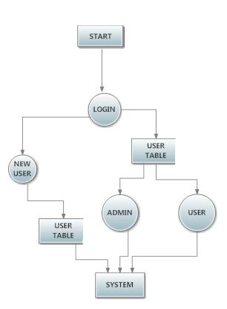

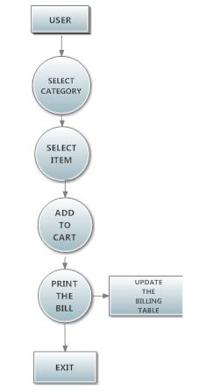

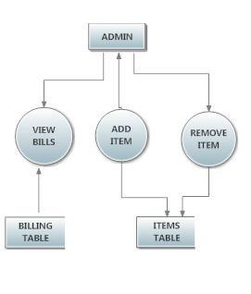

APPENDIX

1. SNAPSHOTS

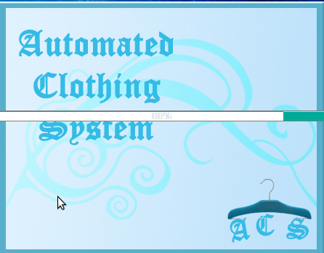

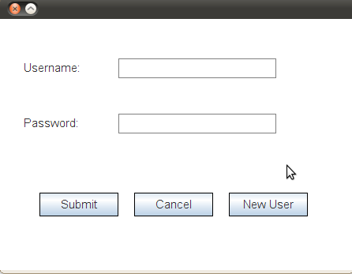

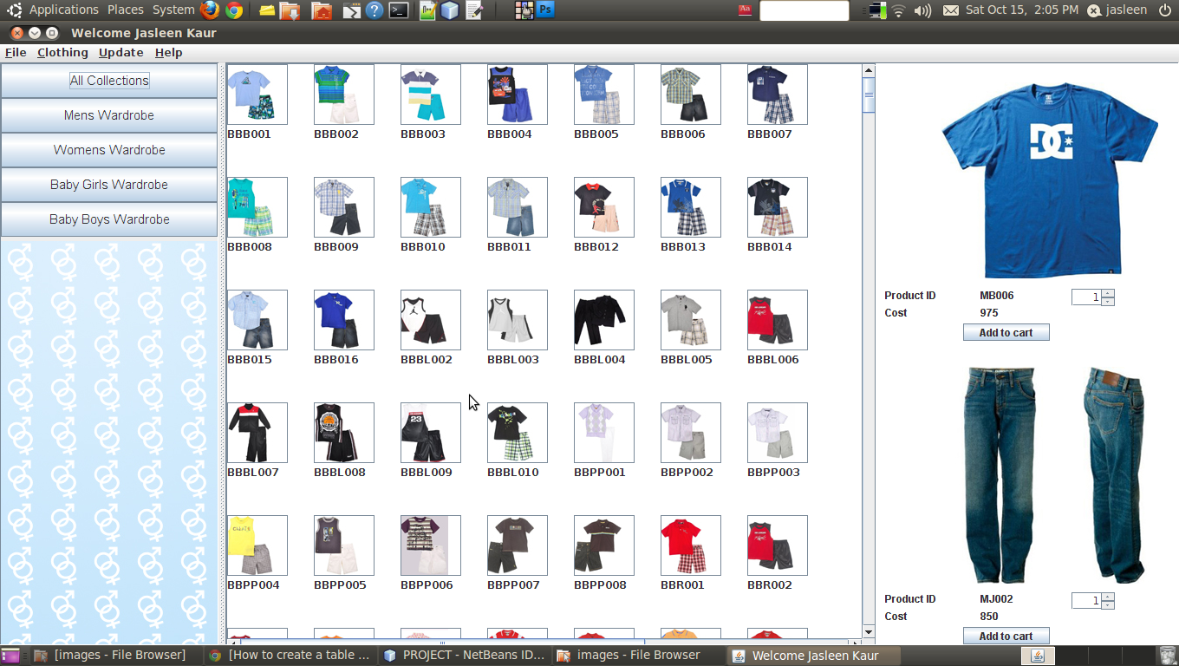

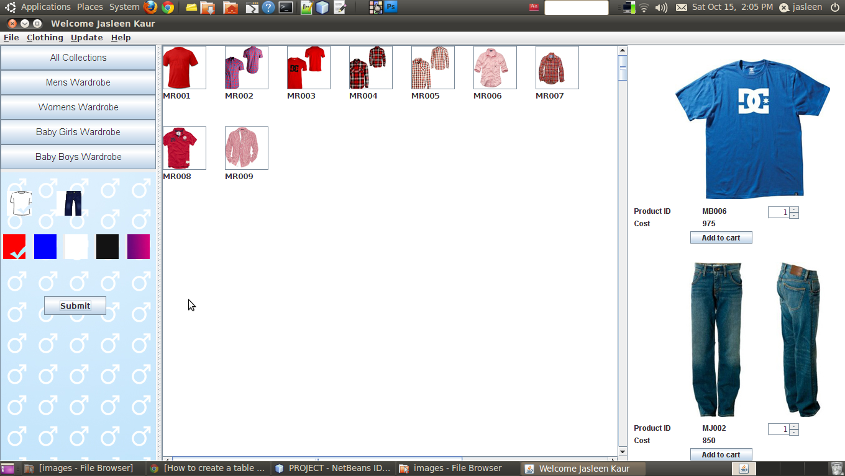

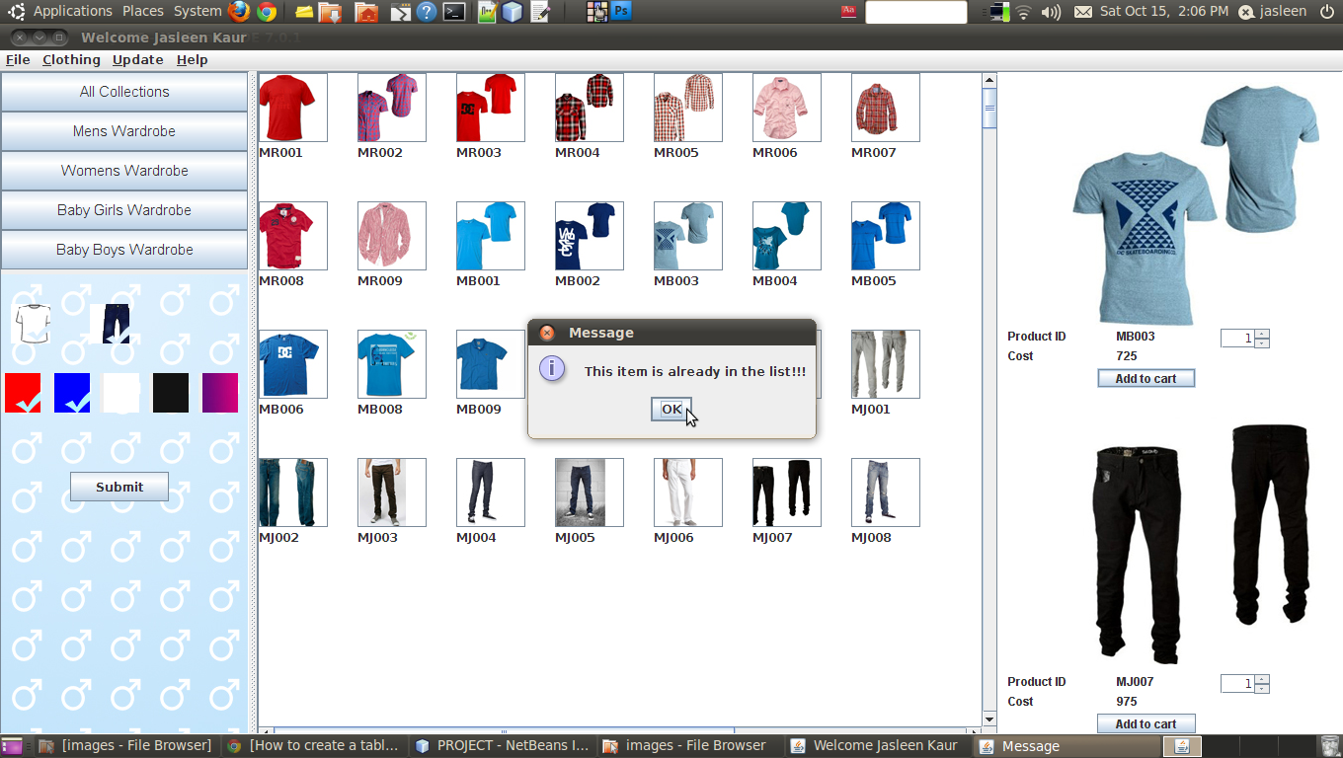

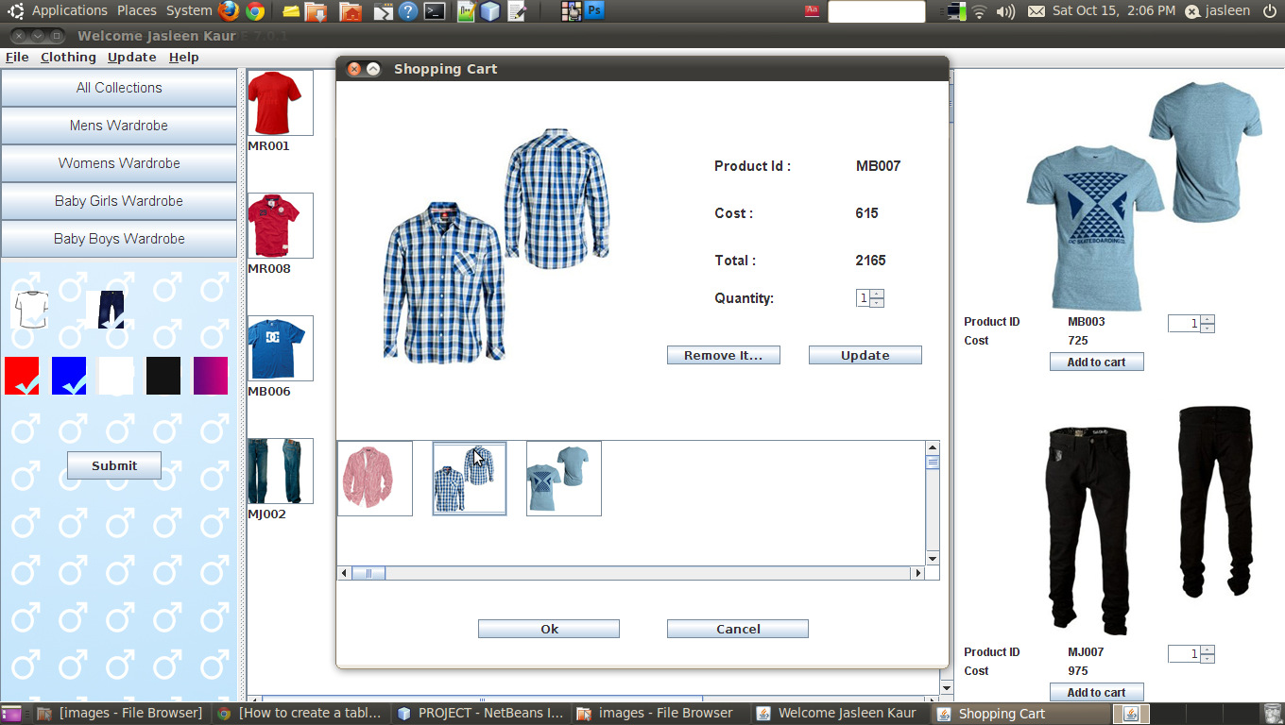

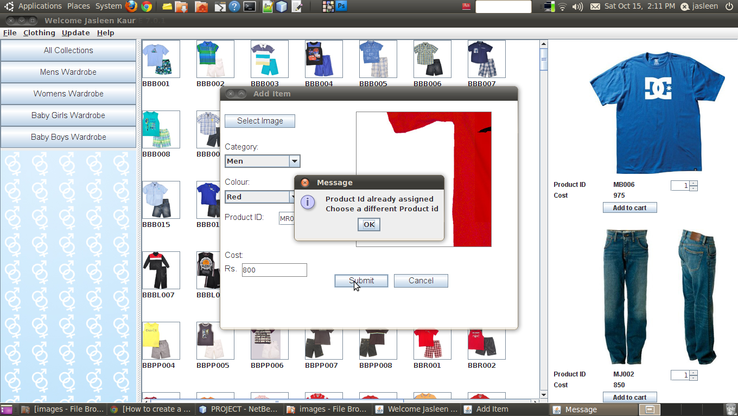

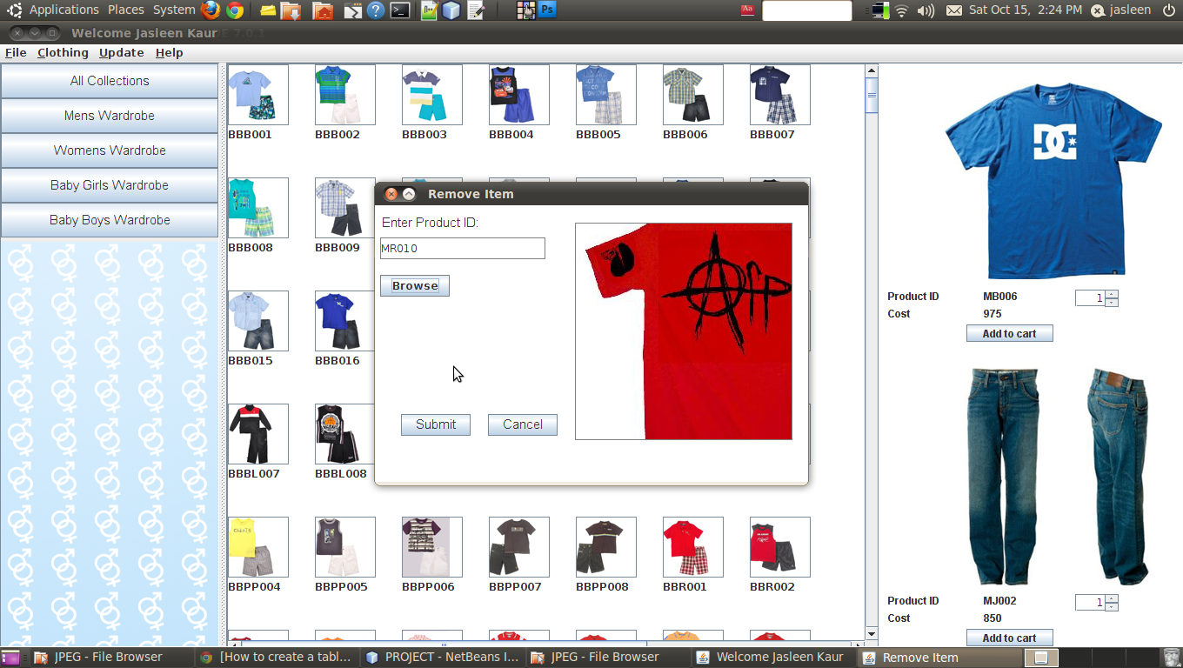

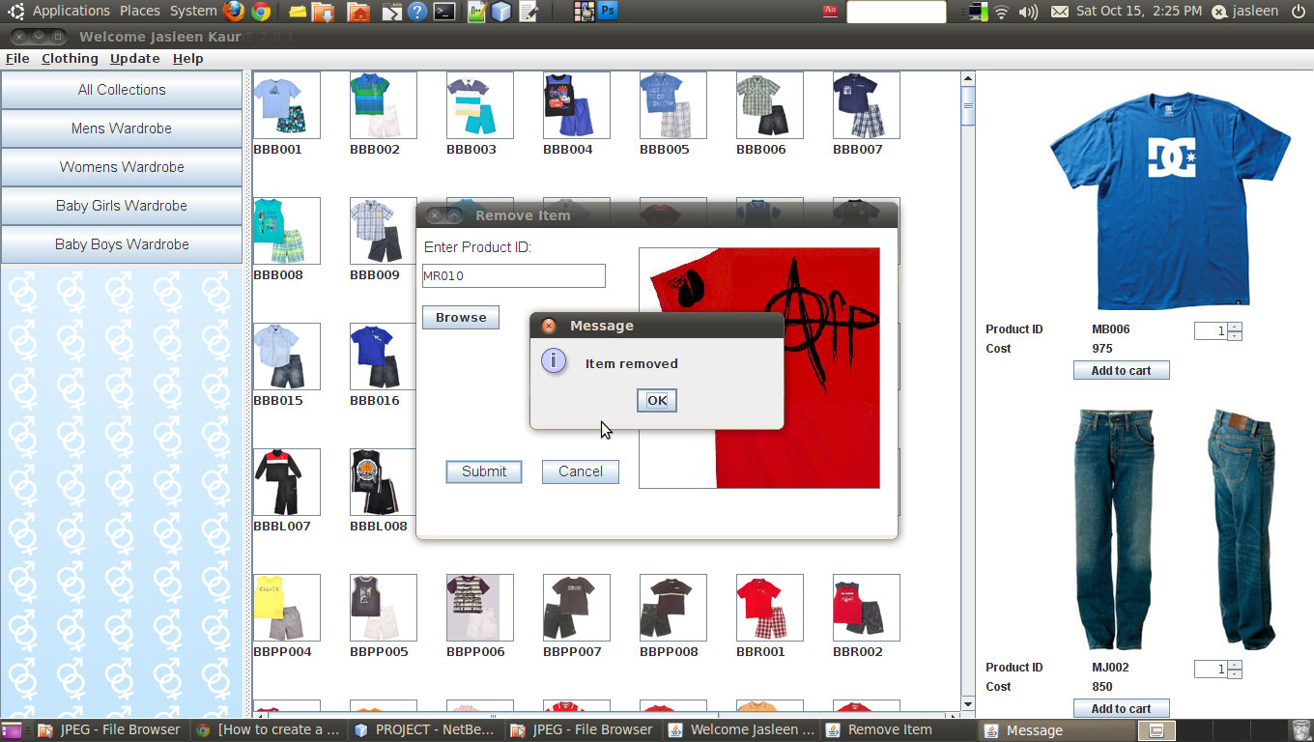

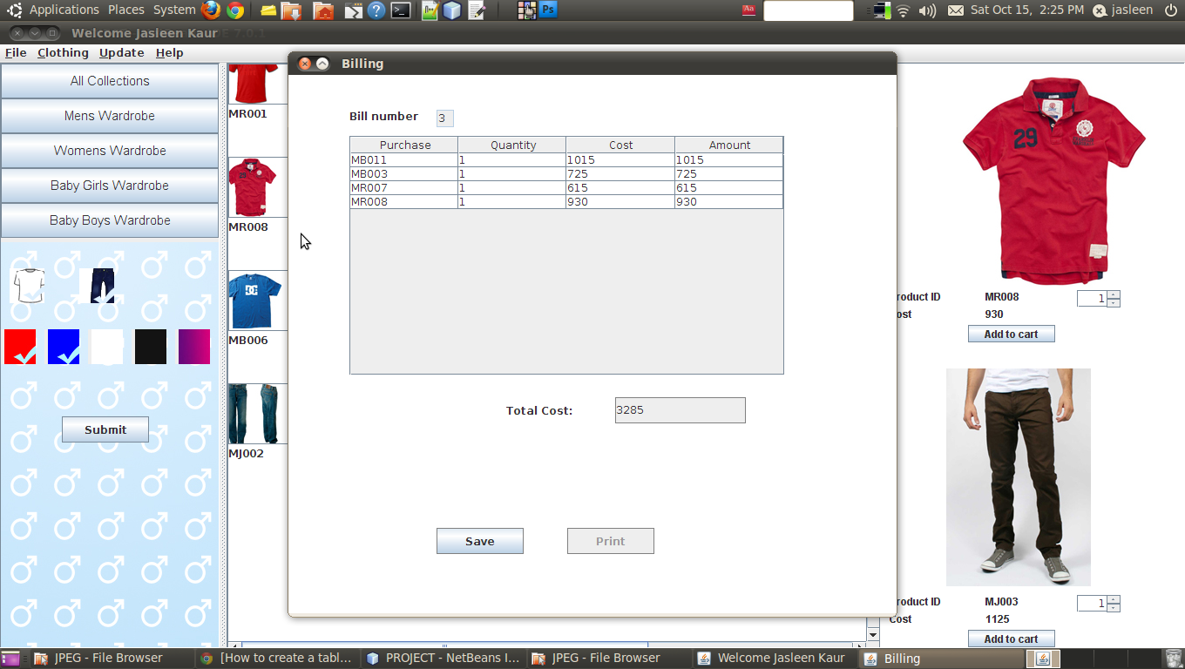

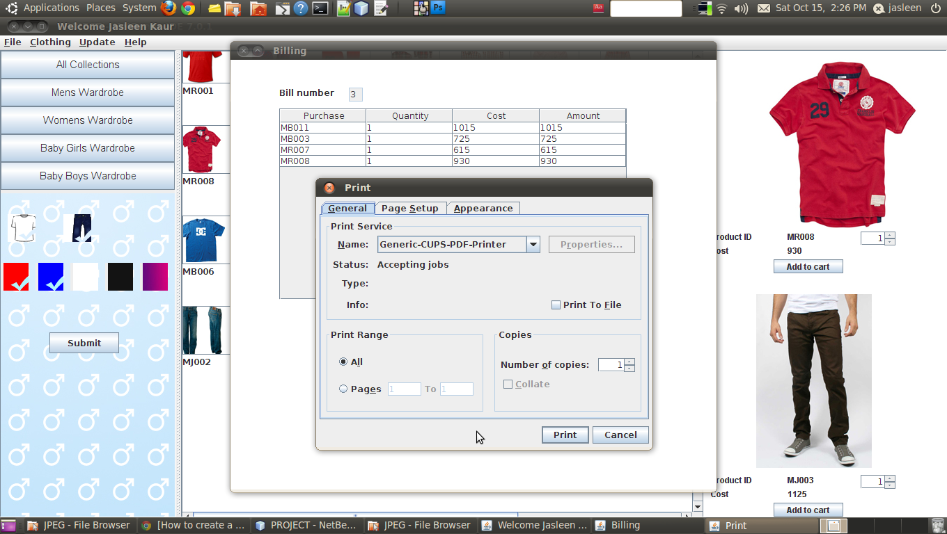

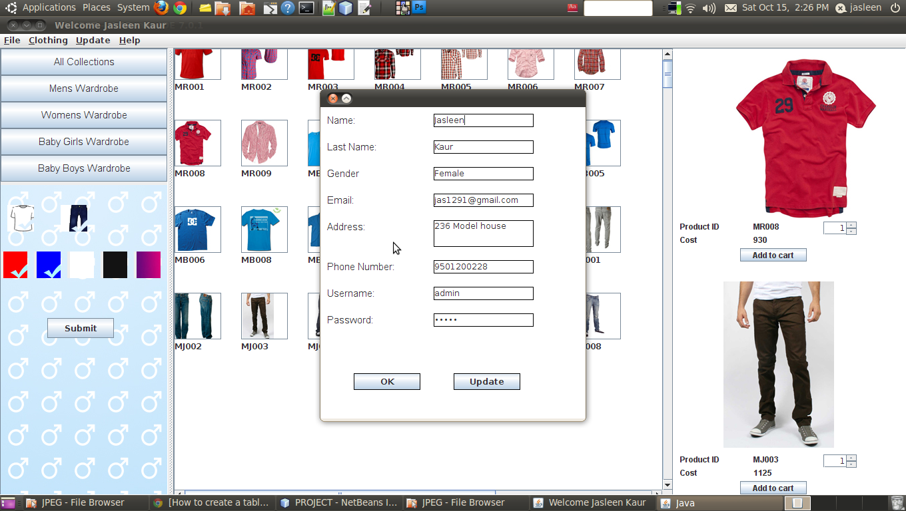

CONCLUSIONS

This project that I undertook was truly a very rewarding experience for me in more than one way. It has given a big thrust to my technical knowledge as prospective Software professional. It has also helped me enhance my skills on the personal front.

And I feel extremely satisfied by the fact that I have managed to develop the project . I think I have exploited the opportunity that came my way to the fullest extent by increasing my technical know-how and also gaining the valuable work experience apart from studying the other subjects in our curriculum.

BIBLIOGRAPHY & REFRENCES

* The Complete Reference Java (Seventh Edition) by Herbert Schildt.
* [www.roseindia.net](http://www.roseindia.net)
* [www.1keydata.com/sql](http://www.1keydata.com/sql)
* Notes provided by the institute